Setting up CPRS for independant access of Custom Control libraries
As the CPRS team expands into more and more libraries it has become evident that a simpler way of managing these controls is needed. This document will outline a streamlined method of installing the components without the need for all the extraneous path definitions we have used in the past. All component source is now stored under a Delphi specific (XE3, XE5, XE8, etc.) directory in Jazz so that developers can run multiple versions of Delphi with separate controls for each version. Before beginning find a directory outside of the Jazz Workspaces to place the compiled packages into. This needs to be outside of the Jazz Workspaces because the new setup uses the compiled units instead of the traditional source code paths where everything is constantly re-compiled into the CPRS project. If the developer wishes to use the same directory as was defined before with the CPRS environment variable that is fine so long as that variable references a directory that is outside of all Jazz Workspaces. With this setup in place all copies of CPRS compiled or built will be using the same versions of the Run Time and Design Time libraries, including the build machine. Once this is completed, code will be added to CPRSChart that will check the versions of the components, further guaranteeing that the final product we release is exactly what we think it is.

To begin we need to uninstall all existing components.
Step 1: Start Delphi but do not open any projects.
Step 2: In the menus selecte Component | Install Packages …
Step 3: The following dialog will display (package names may be different but similar):
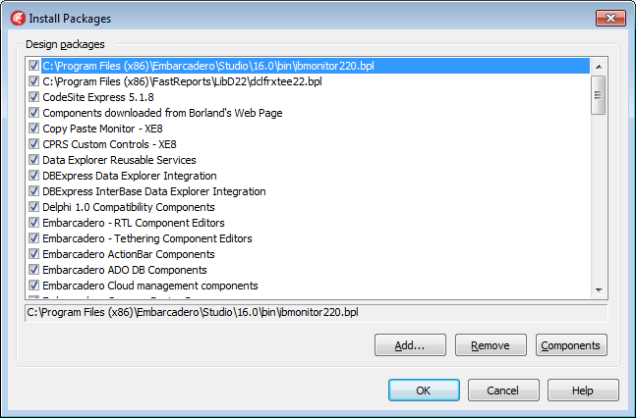
Step 4: Select the following packages and click on Remove to take them out of your configuration. Be sure to ask if you find packages that don't look like standard Delphi packages but may need to be cleared out anyway.
- Copy Paste Monitor – XE8
- Components downloaded from Borland's Web Page
- CPRS Custom Controls – XE8
- VA Section 508 Accessibility – XE8
- VistA RPC Broker – XE8
Step 5: Close this dialog.

Now we need to verify the paths and environment variables. Under the menus select Tools | Options … and the following dialog will be presented. Select Environment Variables.
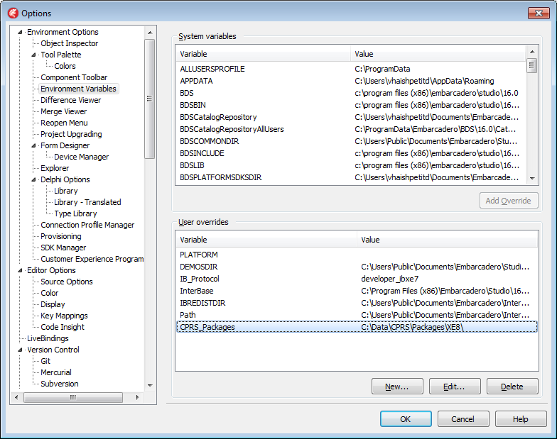
In the environment variables delete any that are specific to the CPRS project (i.e. Broker, PKI, AVLogger etc.). Do not remove any that are sepcific to BDS settings. The example above shows a the new CPRS_Packages variable pointing to the directory that we described at the beginning of this document. Your directory may be different. Again, this is NOT to be the Jazz Sandbox directories. Also notice that the last sub-directory is XE8. This is because the compiled components will be released for each version of the IDE so that changes made to CPRS versions compiled in XE3 will not have to be ported to XE8 unless critically needed to resolve an issue.

Now we need to select the Library settings as shown here.
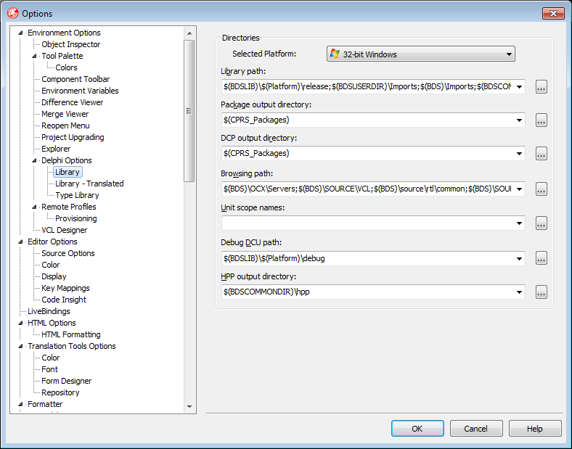
Notice that the Package output directory and DCP output directory are the same. This is where the custom controls will be placed to be accessed by the IDE. Open up the Library path with the […] button.

Previously we setup paths for each component package as shown here.
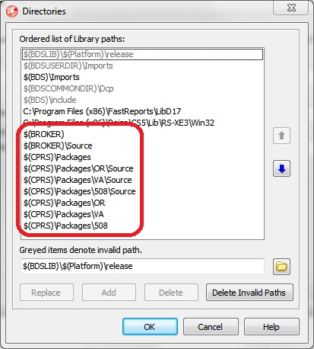
You may also have a patch for the AVLogger as well. We want to clean these up by selecting them in the list and pressing Delete. Do not press the Delete Invalid Paths button.

Now we will add a new two new entries to the bottom of the list for
$(CPRS_Packages)
and
$(CPRS_Packages)\Resource
You should now have a list with the two paths at the bottom as shown:
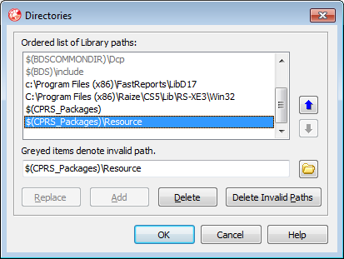
Next, do the same thing for the Browsing path entry. It is important to ignore any invalid paths at this time because we haven't moved the new compiled libraries into the directory.
Shutdown and restart Delphi to let it sort out the new directories. Just agree with what it wants to do if it pops up a dialog about paths.
If this is not a new install, it is a good idea to get a copy of the Scrubbing Old Delphi Components From My Workstation document and do a thorough cleaning of any rogue libraries that may have been created in the past. These libraries are known for cropping up at the wrong time in the wrong place of your path variable and causing weird errors and issues.
Now we take a divergent path from previous setup documents. Developers should obtain a copy of the latest compiled component zip file from (future location to be determined). This zip file will be created as component updates are made available and will be created on the build machine with the proper compiler flags and settings to ensure that every developer is working with the same component libraries thus, producing the same results from workstation to workstation.
This file should be unzipped into the $(CPRS_Packages) directory and the user should see the following directory setup (your root directory may be different):
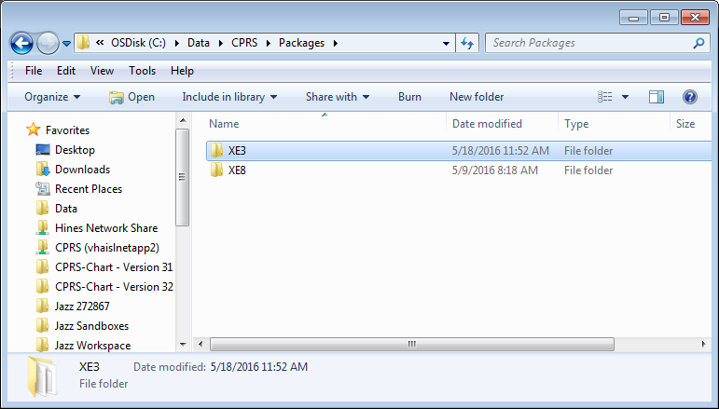
These packages are already compiled and ready to be added to the Delphi IDE. Note that all available versions of the components are released at the same time. However, also remember that we set the XE8 environment variable CPRS_Packages to point to the IDE specific directory for XE8.
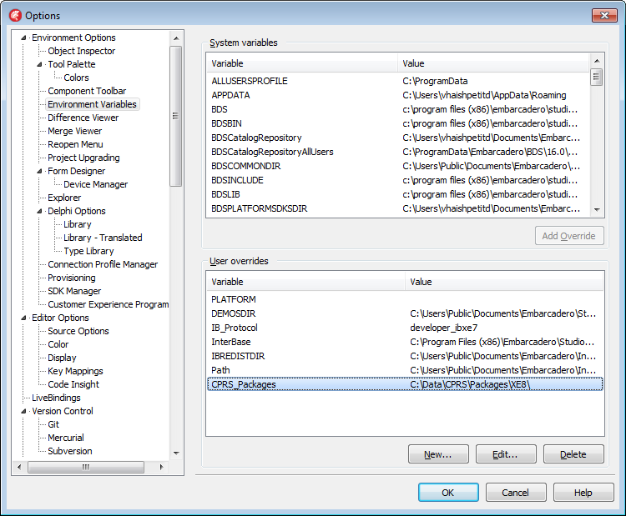
Start up Delphi if it is not already running and follow these steps to place the components onto the Tool Palette.
Under menus again go to Component | Install Packages …
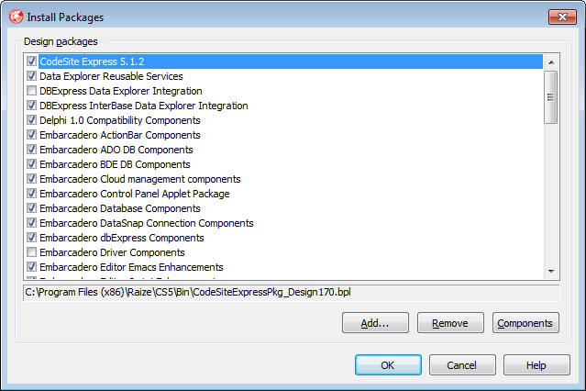
Click on Add … and browse to the IDE specific directory with the compiled units. In this case it is the XE8 directory.

You should see a directory similar to the following.
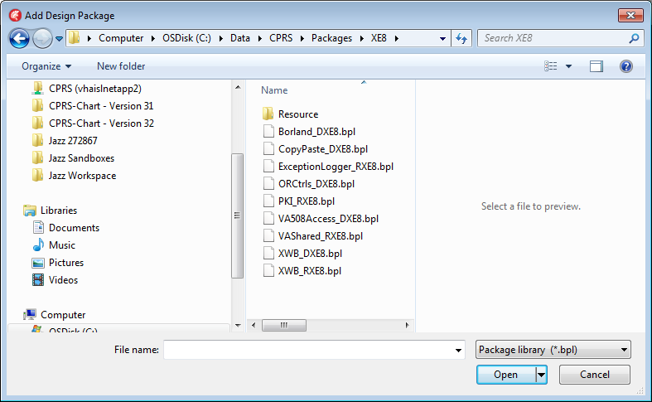
Select the Borland_DXE8.bpl file and click on Open.

You should now see the Design Time package in the Install Packages dialog as shown.
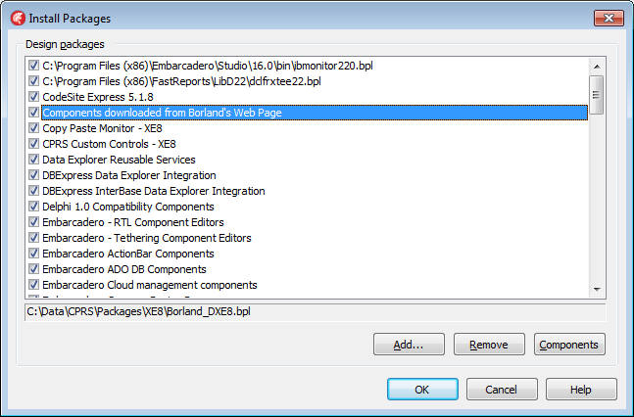
Repeat these steps for the other required Design Time packages listed below. Runtime packages (*_RXE8.bpl) are not installed because they do not interact with the IDE.
Install in the following order:
- VA508Access_DXE8.bpl
- XWB_DXE8.bpl
- ORCtrols_DXE8.bpl
- CopyPaste_DXE8.bpl

You should now see the four packages installed with their respective names followed by – XE8 in the Design packages listbox.

Select OK to close the dialog.
Now open up a blank project and verify that the Tool Palette has the following components showing up on the selected tabs.
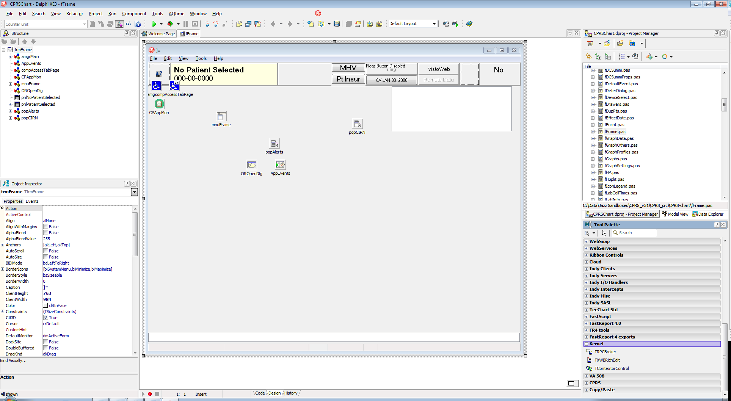
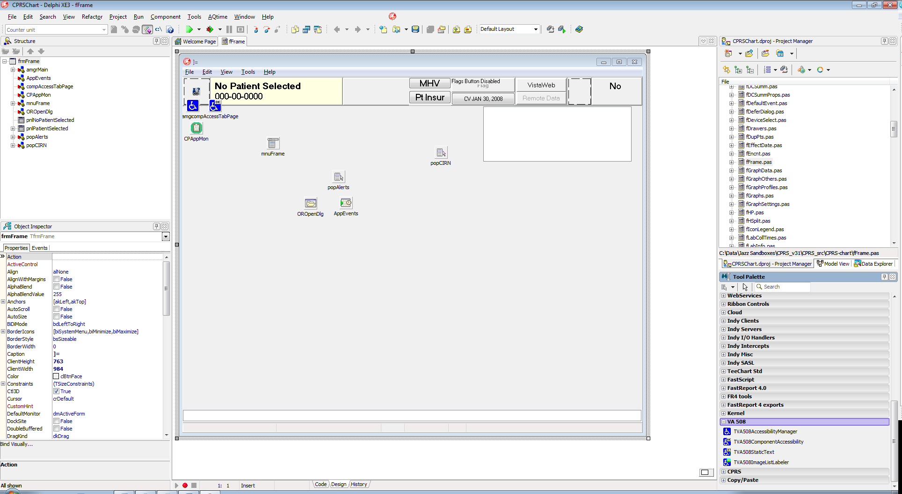
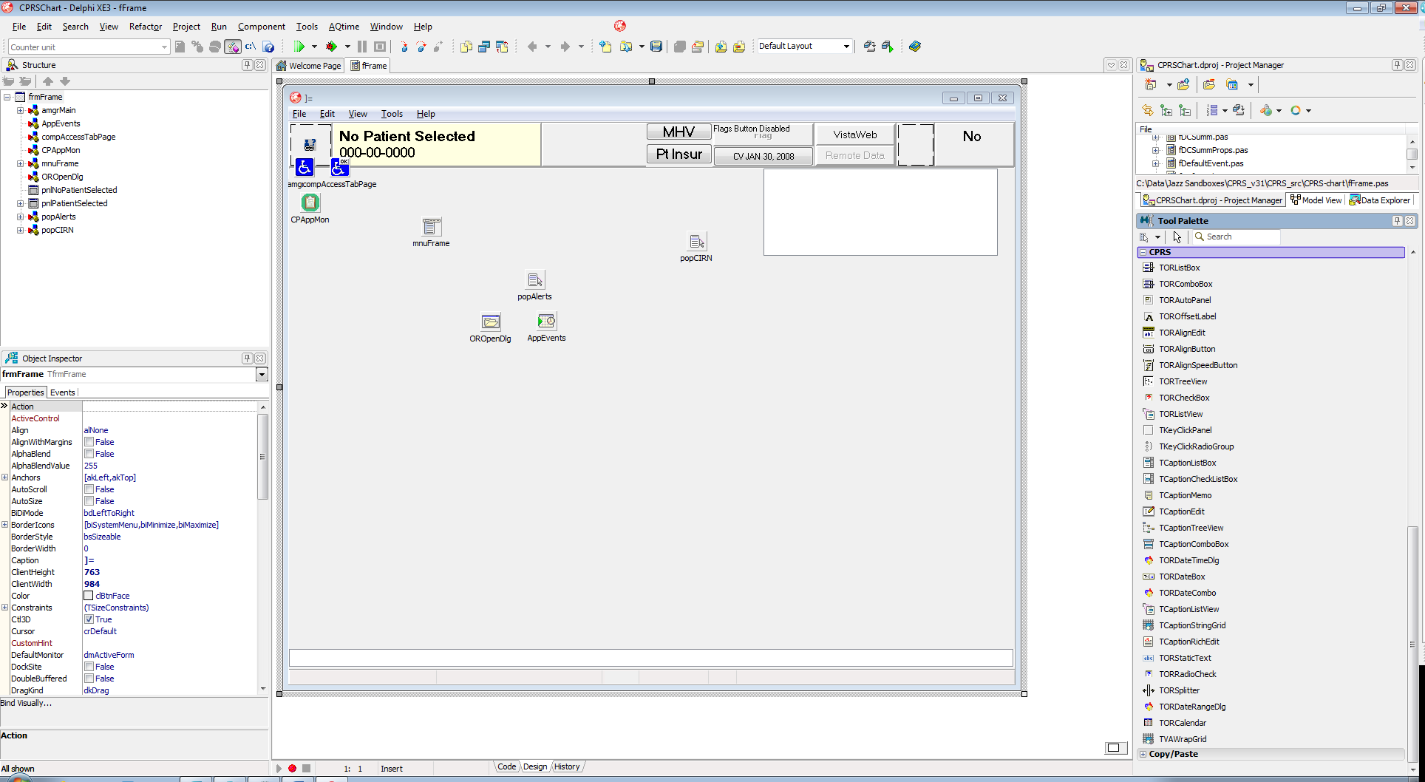
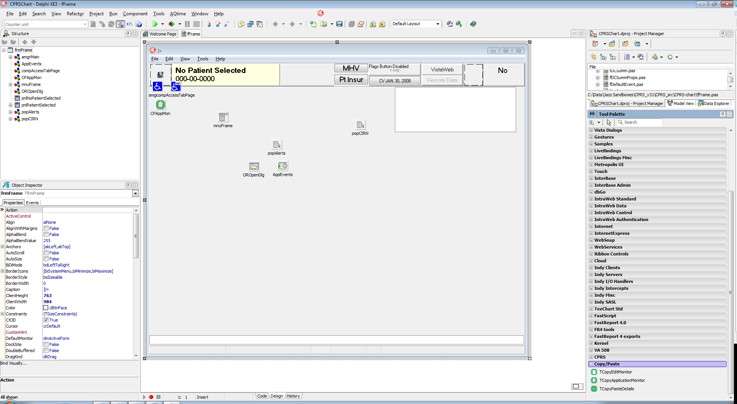

Next open CPRSChart.dproj, and compile. You should not see any errors and your IDE should be upgraded and ready to go.
